  - Using designer fragrances to study behavior in wild felids of the Osa Peninsula
Elizabeth Bean | Capstone | May 2018

Abstract
Wild cats are important in conservation for their role as top carnivores in ecosystems and their cultural and economic value. Monitoring wild cats for conservation is difficult because of their elusiveness, large home ranges, and low population densities. However, camera traps have been proven to be an effective form of estimating population densities. The Osa Peninsula is one of the last landscapes in Central America that can sustain a full range of large cats such as Margay, Ocelots, Jaguarundi, Pumas, and Jaguars. Despite the relatively healthy state of the forests on the Osa Peninsula, wild cat populations could be suffering from genetic drift and inbreeding due to small population size and narrow spatial distribution. Adding hair traps to camera trap stations could be an effective way of noninvasively collecting genetic samples to test for genetic drift. Genetic analysis would allow biologists to determine how susceptible the populations are to a lack of genetic diversity. Experiments in zoological parks suggest that felid species display a variety of behavioral reactions toward designer fragrances, such as Chanel Nº5. If felids display rubbing behaviors against certain designer scents, biologists could apply these scent to hair traps and collect genetic samples. The goal of this project is to compare baseline data collected in January-August 2017 to data collected in January-April 2018 to determine if the use of designer fragrances causes behavioral reactions in felid species on the Osa Peninsula, and to determine how species react differently.
Key words
Herpailurus yaguarondi, Leopardus pardalis, Leopardus wiedi, Panthera onca, Puma concolor

Wild cats are keystone species that occupy large home ranges that often extend past the borders of protected areas. They have a significant impact on ecosystem functions by balancing prey populations and dispersing seeds over larger areas than most small animals. They generate substantial economic benefits for emerging economies in wildlife tourism (F.R Tortato et al., 2017) as they represent some of the most charismatic species and are sought after by national park visitors. Wild cats are most threatened by the effects of habitat destruction and fragmentation, prey depletion, and illegal hunting (Blake et al. 2014). There are 36 species of wild cat found on every continent except Australia and Antarctica (Nowell, K., & Jackson, P.,1992), 5 of which inhabit the Osa Peninsula in south eastern Costa Rica. The Osa Peninsula is one of the last landscapes that can sustain a full range of large cats such as Margay, Ocelots, Jaguarundi, Pumas, and Jaguars in Central America. Of these species, the jaguar has received the most attention with camera trap projects to estimate their abundance on the peninsula and in populations all over the Americas. (Maffei et al., 2011). Since the study by (Maffei et al. 2011), 83 different camera trap projects had been carried out to survey jaguars all over the Americas. Camera traps have been proven to be the most effective way to monitor wild cat populations in difficult neotropical conditions (Blake et al. 2014), but using camera traps to estimate population density has limitations. Factors like camera failure, low wild cat densities, short survey periods, and lack of local knowledge about wild cat travel routes and failing to place cameras in such areas result in inaccuracies (Maffei et al., 2011). Data from camera traps can confirm a minimum population of a species in an area with some individuals positively identified, and camera trap videos can provide a detailed look at animal behavior. According to Maffei et al. (2011), it is unknown if baiting camera traps with scent increases capture probabilities, but jaguars are known to explore scents, and that could result in multiple videos from different angles and aid in identification.
Camera traps can be used to identify individuals, but they cannot be used to determine if captured individuals are related to one another. However, if felids react to scent baited camera stations by rubbing against the scent, hair samples could be taken with hair trap designs that have been used to collect hair samples from bears, like those in a study by Berezowska-Cnota et al. 2017). By collecting hair samples, scientists can perform genetic analyses to determine individual identification, population characteristics, substructure, movement, relatedness, and population bottlenecks (Kendall & McKelvey, 2008).
It is well known in zoological parks that the application of designer fragrances and scents in animal habitats provoke cheek rubbing behavior in large cats (Thomas et al., 2005). Zookeepers apply a variety of perfumes to objects in felid enclosures to keep their brains occupied and break up the monotony of captivity. Experiments have been conducted with captive individuals that observe preference and behavioral reactions to different brands of fragrance. At the Bronx Zoo, consistent preferences have been observed toward Calvin Klein’s Obsession for Men and L’Air du Temp perfume (Thomas et al., 2005). At the Vesty Pakos Municipal Zoo in La Paz, Bolivia, Chanel Nº5 was applied to jaguar enclosures and the study recorded a much stronger reaction to the scent than Calvin Klein’s Obsession for Men (Viscarra, 2011). This is the only published study that uses Chanel Nº5 in recording felid behavior. Calvin Klein’s Obsession for Men seems to be the most well-known scent to use in felid studies, however this might be because most studies don’t use Chanel Nº5 since it is more than 4 times the cost of Obsession for Men. Reactions toward Calvin Klein’s Obsession for Men have been tested on captive ocelots, amur tigers, and cheetahs, but each species and gender within a species showed different behavioral results (Thomas et al., 2005).
In addition to the literature, Chanel Nº5 is important because it is most commonly known among local naturalist guides on the Osa Peninsula to attract Jaguars.
In the field, biologists have applied scents to hair traps to attract felids to collect hair samples for DNA analyses from the Canada lynx (Lynx canadensis) and ocelots (Leopardus pardalis) (Weaver et al., 2003). However, there is a lack of conclusive studies determining the effectiveness of using specific fragrances to attract and collect hair samples of wild felid species.
This study analyzed the possible behavioral responses of wild jaguars, pumas, ocelots, margay, and jaguarundi to the application of designer fragrances in established camera trap stations. The results were compared with baseline data to determine differences in the felid’s behavior toward three perfumes that have seen high behavioral results in captivity: Chanel Nº5, Calvin Klein’s Obsession for Men, and L’Air du Temp perfume (Thomas et al., 2005 & Viscarra, 2011). While captive cats are drawn to a wide variety of fragrances, it is important to assess the response of free-ranging felids to designer fragrances because they are unfamiliar and interesting or avoid scents because they may be associated with human activity. This project was designed to observe behavioral response to designer fragrances that could justify genetic analysis projects with the use of designer fragrances.
The three specific fragrances: Chanel Nº5, Calvin Klein’s Obsession for Men, and L’Air du Temp were chosen because they had significantly stronger reactions than other tested fragrances, according to the literature. For example, Calvin Klein’s Obsession for Men and L’Air du Temp showed the highest frequency of responses of the twenty-four fragrances used (Thomas et al., 2005). Chanel No. 5 was not used in this study.
Chanel Nº5 is the most important of all the fragrances because in a study done at the Vesty Pakos Municipal Zoo, Chanel Nº5 showed more than five times the frequency of responses than Calvin Klein’s Obsession for Men. The study used three commercial scents in 14 individuals and observed behavioral responses of captive Jaguars. Among the three perfumes, Chanel Nº5 induced high to medium-intensity reactions more frequently, as well as a longer lasting behavioral response specifically in the “Whirling” behavior for periods of approximately 3 minutes (Viscarra, 2011). The study recommends using Chanel Nº5 when carrying out research with wild jaguars.

Scent
When perfumes like Chanel Nº5 were first created, they were composed of natural ingredients and only available to the wealthiest people due to the high cost of these ingredients. Common base note ingredients for perfumes like Chanel Nº5 were originally made with musks obtained from various animals such as musk deer, Moschus moschiferus, and civet cats of the family Viverrinae (Choo et al., 1994). Civetone (9-cis-cycloheptadecenone), commonly known as civet, is a major macrocyclic ketone found in the glandular secretion of civet cats (Choo et al., 1994). Civetone is a 17-membered macrocyclic ketone carrying musk odor, which attains a pleasant smell in extreme dilution (Choo et al., 1994). Civetone has been successfully synthesized and is used in Chanel No. 5 and Obsession for men (Fortineau, 2004).
Synthesizing chemicals to make perfume started to grow with the development of organic chemistry. (The term “note” is used when talking about perfume in place of the word ingredient). Chanel Nº5 was created in 1921, but only recently after pressure from animal rights activism have they began synthesizing civetone. Synthetic civetone in Chanel Nº5 and Calvin Klein’s Obsession for Men could be the ingredient that explains alleged large cat reactions to the scents. Although the civet cat is more closely related to a mongoose than a cat, the pheromones associated with the scent of synthetic civetone could explain the scent rubbing behavior seen in zoological studies where perfumes containing civetone were applied. New world cats have never encountered Civets, but it is hypothesized that civetone could mimic a pheromone produced by wild cats.
Different felid species display scent rubbing behavior in different patterns. Interpretations by Rieger, (1979) conclude that feline cheek rubbing is not a scent marking behavior, but a scent rubbing behavior wherein the animal rubs its head on the nearest protruding object. Rieger states that scent rubbing might be a “vestige of phylogenetically old scent marking behavior” from ancestors of the carnivore family when scent rubbing behavior was integrated in the scent marking pattern.
Chemical signals such as Cat Passion and Wild Cat have widely been used carnivore attractants (Pacheco et al. 2003). However, these attracts are difficult to get outside the United States, so this study observes the various behavioral scent rubbing reactions in felid species to fragrances for humans.

Study Area
The study conducted Jan 2017-August 2017 and Jan 2018-May 2018 at a 52.6-hectare biological station on the Osa Peninsula on the North border of the Corcovado National Park (Puntarenas Province, Costa Rica 8.639996 N, -83.731940 W). The exact location is shown in figure 1 represented by a red dot. Protected areas are forested. Unprotected areas consist of fields, roads, and small towns.
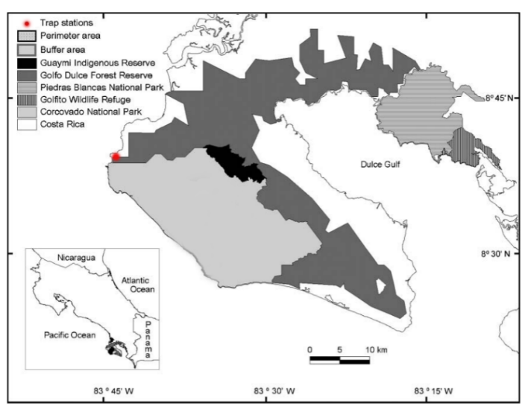
Figure 1. Map of the Osa Peninsula and protected areas (Salom-Pérez et. Al 2007)
The Osa Peninsula is one of the last landscapes that can sustain a full range of large cats such as Margay Leopardus wiedi, Ocelots Leopardus pardalis, Jaguarundi Herpailurus yaguarondi, Pumas Puma concolor, and Jaguars Panthera onca in Central America. Populations of these species have been in decline due to land conversion and hunting. Conservation efforts such as the creation of the Corcovado National Park and other biological reserves on the peninsula were made to avoid their local extinction. Now most of the peninsula is protected (figure 1). There is a rainy season from May to November, and a dry season from December to April. The habitat type is a lowland tropical rain forest. Primary forest is found both inside and outside the study site. The landscape of the Osa Peninsula is a mosaic of secondary forest with open areas for agricultural and livestock use with a human population scattered throughout the peninsula congregating around the districts of Drake and Puerto Jimenez. Tourism is the largest economic sector on the peninsula. Potential natural prey for wild cats on the peninsula include, among others, agouti (Dasyprocta punctata), paca (Cuniculus paca), monkeys (Alouatta palliata, Cebus capucinus and Ateles geoffroyi), coati (Nasua narica), peccaries (Pecari tajacu and Tayassu pecari), and Central American red brocket deer (Mazama temama). Wildlife poaching is declining due to increased tourism, but it still occurs on the peninsula both in and outside protected areas. The closest urban development (Drake Bay, population 7,000) is located 18 km north of the study site. A growing number of education campaigns to provide an understanding of the importance of biodiversity and predators in the area have resulted in the appreciation for the revenue that live animal sightings through ecotourism can bring (UCIN, 2009).
The study site experiences very little human activity as the biological station is only reachable by boat. There are no roads. Therefore, many felines and feline prey have been sighted and captured on cameras there. For this project, cameras were placed along the border of the National Park.
Methods
Baseline Data: A two-week pilot study was conducted in 2017 wherein, five Stealth Cam camera traps were set up in stations with one camera at each station in locations where a water source, tree fall zone, trail crossing, or tracks where present. Cameras 1-3 were placed on human built trails, and cameras 4 and 5 were placed in locations off the trails. A sixth camera was placed in the emergent level of a strangler fig (F. aurea) enveloped tree 30 m off the ground to detect arboreal margays (L. wiedii) or potential felid prey. The ground level traps were mounted at a height of approximately 45 cm from the ground on trees and the cameras were programed to run 24 hours a day and to fire as soon as the beam was broken with a five second delay between videos. Videos were programed to record for 30 seconds. Each video of an individual marked a “capture occasion”. Capture occasions were then compiled into a survey.
After the initial pilot study data were collected in December 2017, 3 optimal frequency stations were determined to be the Ridge Trail Station (CAM 1), Cliff Trail Crossing Station (CAM 2), and the Toucan Trail Station (CAM 3). These stations remained permanent throughout the entirety of the 2017 study, and camera stations 4 and 5 were used to test for other optimal frequency zones in various locations. According to Silver (2004), the technique for jaguar surveys should not be based on random sampling, but rather, sampling based on locations that maximize probability for all animals in the sampled area to be captured. Locations with high probability of capturing all animals in an area are referred to as “optimal frequency zones.” Optimal frequency zones include characteristics like manmade or animal made trails, water sources, tree fall zones, and places where animal scat or vomit has been previously found. Videos were collected every two weeks and general maintenance of the cameras was also conducted during this time (changing batteries, de-humidifying, switching memory cards and formatting cards). No lure or bait was used at any station to attract the felines. No camera trap stations were baited with fragrances for this initial study to avoid altering the natural behavior of the felids. These data now serves as the control for the fragrance experiment.
Populations/ Relative Abundance: The presence and relative abundance of potential prey was assessed by recording the number of captures of each species. A list of potential mammal and bird prey species was built from these captures. The presence and relative abundance of wild cats was assessed by the recording of puma (P. concolor), ocelot (L. pardalis), and jaguarundi (Herpailurus yaguarondi) captures. Captures of unidentifiable species due to camera malfunctions or lack of trigger speed were excluded from the results.
The baseline study obtained videos of 29 different species of birds and mammals and captured 27 videos of wild cats (Table 1). The most frequently recorded wild cat was the puma. Two individual pumas and two ocelots consistently visited with overlapping territories. The study also showed many possible prey species including the rare white lipped peccary. The two most recorded mid-sized species were the agouti and coati. The most frequently recorded large-sized prey was the tapir and even a young juvenile tapir.

Table 1. Frequency of observation for mammals and birds at each camera station

Species | CAM 1 (Ridge) | CAM 2 (Cliff crossing) | CAM 3 (Toucan) | CAM 4/5
Mammals
Leopardus pardalis | 2 | 5 | 2 | -
Puma concolor | 5 | 9 | 3 | 2
Dasyprocta punctata | 16 | 5 | - | 2
Nasua narica* | 9 | 1 | - | 8
Tayassu tajacu* | 9 | 3 | - | 1
Tayassu pecari* | 1 (60+) | - | - | -
Cuniculus paca | 3 | - | - | 4
Eira barbara | 1 | 1 | - | 2
Cricetidae (rat family) | - | 1 | - | -
Caluromys derbianus | - | 18 | - | -
Didelphis marsupialis | 1 | 1 | - | -
Procyon lotor | - | 2 | 2 | 2
Mephitis macroura | - | 1 | - | -
Tamandua tetradactyla | - | 4 | - | -
Tapirus bairdii | 8 | 2 | 18 | 7
Mazama americana | - | - | - | 1
Domestic dogs | 2 | - | - | -
Birds
Crax rubra* | 9 | 1 | 2 | 2
Sarcoramphus papa | - | - | 1 | -
*All species of COATI, CRAX RUBRA, and peccaries were counted as troops.

The previously established camera trap stations were reconstructed in December 2018 to run for a total period of 4 months (January-April).
A pilot study was conducted in December 2018, wherein camera stations were tested with two cameras at each station, at approximately a 45º angle to a scent lure (Figure 2). This preparation was executed based on a study by Berezowska-Cnota et al. (2017) which found that when baiting scent traps ten weeks prior to monitoring, sampling effectiveness can reach up to 30% with the brown bear. Their study states that is it important to bait traps in advance to increase sampling effectiveness because bear tree rubbing enhanced rubbing behavior by other individuals with time. This may also be true with fields. Just as in 2017, each camera had two designated memory cards that were not shared between cameras. This technique helps keep data organized and minimizes memory card malfunction.
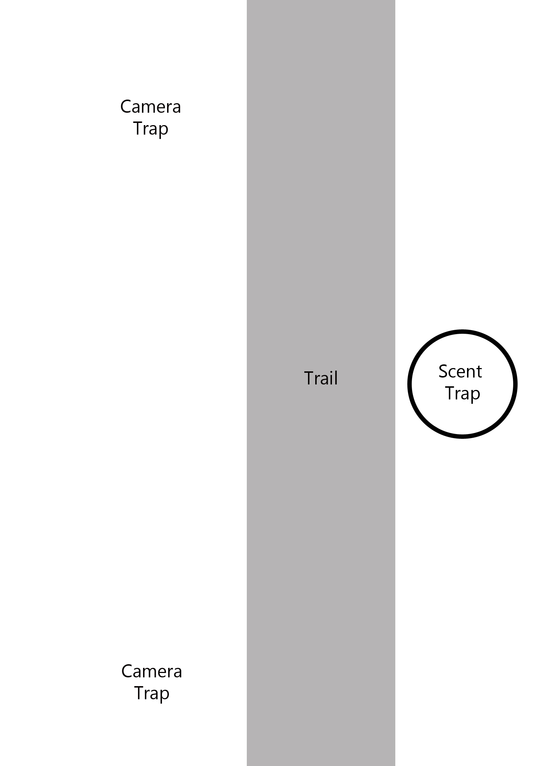
Figure 2. Diagram of camera trap stations
The project had four camera stations running in the determined optimal frequency zones. In other words, trail cameras were stationed in areas that have been identified as high traffic locations, mostly in trail intersections and near fresh water sources. Jaguars and other felines use regular travel routes and often return to the same sites (G.B. Schaller, 1980). Using trail intersections, freshwater, and direct signs of wild cats were successful techniques in determining optimal camera placement zones, and sufficient data was received on wild cat populations on the study site to conduct this behavior study. Since Jaguars have very large home ranges, the camera stations were spaced as widely as possible across the property to facilitate a larger sampling area (G.B. Schaller, 1980). One of these stations served as the control and was not baited with scents. Three of the stations were baited with designer scents to determine whether species are attracted or repelled by the scents.
Unlike the last study, each camera trap station was equipped with two cameras to capture a better documentation of behavior and to easily identify individual wild cats. The beams were set at the same height of about 45 cm from the ground. The date, time, temperature, and coordinates were recorded with each video and compared to the captures of the control study. Each capture video is 30 seconds long with no delay between each video if there is continuous motion. Continuous videos are only counted as one capture. The cameras use black and white infrared without a flash and do not disturb animals or affect their behavior. Videos from these cameras are effective at capturing sound and can record vocal responses. Each video of an individual marks a “capture occasion”. Capture occasions were compiled into the survey to determine if the animals are using the same travel pattern, both in the controlled and experimental stations. Each station captured two videos from two cameras at different angles of each capture occasion. Two videos of the same capture were recorded as one capture occasion. The capture-recapture model was used to estimate populations by identifying individual spotted cats by their rosettes and recapturing them in another capture during the survey. In this model, it is assumed that no individual with a territory in the study site can have a zero percent capture probability (Maffei et al., 2011). It is also assumed that the population is closed, meaning there is no immigration, emigration, births, or deaths, during the study (Maffei et al., 2011).
Experimental Stations:
At each of the three experimental stations, one of three scents were applied in view of both cameras of the station. The behavioral data collected from experimental stations includes:
- Species & gender
- Inspection of scent
- Contact/interaction time with the scent
- Observed behaviors toward the scent/ behavior score (ex. cheek rubbing, whirling, sniffing, starring)
Measured amounts of Chanel Nº5, Calvin Klein’s Obsession for Men, and L’Air du Temp perfumes were applied to the camera stations at the same level as the camera lenses. Fragrances were switched to randomly chosen locations mid-way through the project to avoid bias from variables at each location. The stations for the first half were assigned as follows:
Location | Fragrance
Ridge Trail Station | Chanel Nº5
Cliff Trail Crossing Station | Calvin Klein’s Obsession for Men
Nature Trail Station | L’Air du Temp
Toucan Trail Station | None - Control
The stations for the second half were assigned as follows:
Location | Fragrance
Ridge Trail Station | Calvin Klein’s Obsession for Men
Cliff Trail Crossing Station | L’Air du Temp
Nature Trail Station | None - Control
Toucan Trail Station | Chanel Nº5
Since the study was conducted in the dry season, rainfall did not tamper with the applied scents. The scent lures were applied similarly to the study by Schmidt & Kowalczyk (2006) with slight modifications. Scent lures were applied with a pipette to small squares of carpet attached to a tree. Each fragrance was mixed with glycerin, to prevent drying, in a ratio of 6:2. Carpet squares had a hard-plastic backing, preventing the fragrance from contaminating the tree. 10 ml of the fragrance mixture was applied every 10 days (before memory cards fill up). Schmidt & Kowalczyk (2006) used 5 ml of scent lure for reapplications, but 10 ml measurements were continuously used in this study since they placed scent lures on known Lynx latrines, therefore increasing the chances of visitation by the Lynx.
Carpet squares were placed at a minimum height of approximately 60 cm to be convenient for fields because they prefer rubbing with head areas (Reiger, 1979).
Control Station:
The control station monitored felid and other animal activity without the interference of added fragrance. The control station was chosen at random to avoid bias.

Results
During the study, the Chanel No. 5 station collected five total passing felid captures with no rubbing reactions. The Calvin Klein Station collected six captures of passing felids with no reactions to scent. The L’aire du Temp Station collected a capture of the jaguar cheek rubbing the scent. (Table 2). These results show over the course of four months, eleven captures of three different felid species (ocelot, puma, & jaguarondi) showing no reactions to scent traps. The only felid species that responded to a scent trap was the jaguar. However, a male tapir contaminated the station nine days prior to the jaguar capture by marking his territory in the direction of the scent tap. Because of this contamination it cannot be determined if the jaguar was provoked to cheek rub by the scent of L’Aire du Temps or by the scent of the tapir marking.

Of the thirteen felid captures, only two captures were caught by both cameras at the station. The other eleven captures were caught by only one camera at the station. This proves that it is very important for camera trap studies to have two cameras at each station. Otherwise, many capture opportunities can be lost.
Table 2. Frequency of felid captures and reactions
Date Month/day | Felid Species | Scent | Reaction to scent
12-21-2017 | Puma | Obsession | None
12-21-2017 | Puma | Chanel | Looked in the direction of scent for 10 seconds
12-28-2017 | Puma | Chanel | None
1-17-2018 | Puma | Obsession | None
1-17-2018 | Puma | Chanel | None
1-20-2018 | Jaguarondi | Obsession | None
2-5-2018 | Puma | Obsession | None
2-11-2018 | Ocelot | Obsession | None
3-21-2018 | Puma | Obsession | None
4-5-2018 | Ocelot | Chanel | None
4-7-2018 | Jaguar | L’Aire du Temp | Rubbed sent for entirety of video (10 sec.)
4-8-2018 | Jaguar | L’Aire du Temp | Smelled for ~5 sec.
4-122018 | Jaguarondi | Chanel | None

It is also worth noting that White Lipped
Peccaries demonstrated the only reactions to the Calvin Klein Scent trap with aggressive teeth clacking. They jumped away from the scent with back hair raised. It is unclear whether the reaction was provoked because the scent was unfamiliar or because it smelled like danger. The peccaries intently smelled the scent in various occasions during the night. During the day they walk with their noses to the ground and did not stop to smell the scent.
Discussion and Management Implications
Rubbing is a common behavior among cats as an element of scent marking (Schmidt & Kowalczyk, 2006) and in zoological parks this behavior has been observed very strongly with the scents used in this study (Viscarra, 2011, Thomas et al., 2005). The results of this study indicate that designer fragrances could potentially aid in obtaining hair samples when applied to hair traps from the jaguar. It does not indicate that scented hair traps would be successful in obtaining hair samples from any other felid species of the Osa Peninsula.
In studies whose objective is the collection of hair samples for molecular monitoring in ocelots, jaguarondi, or pumas, I suggest the installation of a scented rub pad in a point of interest such as a known latrine. A more advanced selection of marking sites for the scent traps could likely increase success in rubbing reactions. Hair traps for wild felids could have more success if the scent used was a pheromone from the same species instead of synthetic fragrances. Schmidt & Kowalczyk used beaver castoreum and imitation catnip oil as scent lures for the Canada Lynx with a 50% success rate on Lynx marking sites with corners or protruding parts. This technique could be used for species on the Osa Peninsula if the project included at least 153 marking sites (as found by Schmidt & Kowalczyk). However, this approach is much more difficult in a tropical environment where snow tracking is an impossible method of find felid marking sites.
I recommend using the designer fragrance, L’Aire du Temps in scented hair traps for jaguar studies. However, further zoological studies should be carried out to determine if jaguars choose to cheek rub tapir pheromones over designer perfume.
In addition, a longer study must take place to prove the theory that Chanel No. 5 and Obsession for Men would provoke cheek rubbing behavior in wild jaguars as it does in captive jaguars. The study should now be improved by setting up stations near the L’Aire du Temps station where the jaguar was captured to determine if he chooses to cheek rub one station more than the others.
The jaguar capture in April has huge implications for jaguar conservation on the Osa Peninsula. Four years ago, a photographer named Tico Haroutiounian photographed the same jaguar on the other side of the Osa Peninsula. This means the jaguars territory is at least 48.52 kilometers long (figure 3). This photographer along with Osa Conservation are using this information to coax the government to build a wildlife corridor connecting the Osa Peninsula with the National Park Amistad, which also has a jaguar population.

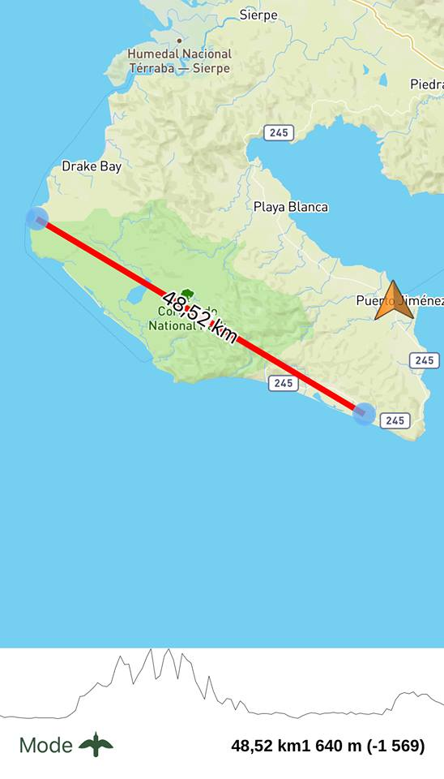
Figure 3. Distance traveled by captured jaguar in four years

Acknowledgments
The results of this project will be recorded in the Proyecto MACOBIO in collaboration with the Ministry of Environment & Energy thanks to Adolfo Artavia.
I thank Washington & Jefferson College for allowing me to conduct this study as a thesis and for supporting innovation and creativity in education. I thank Dr. East and the anonymous reviewers for funding this project with a Mazingira Grant. I thank Dean Judy Kirkpatrick and Dean Michael Shaughnessy for their accepting of such an unconventional proposal. I would also like to thank Dr. James March, for spending countless hours editing and brainstorming with me for this work.
I am grateful to the owner of the biological station, Leonidas Ramsey, for his support and encouragement in conducting this project and his help in the field.

Literature Cited
Berezowska-Cnota, T., Luque-Márquez, I., Elguero-Claramunt, I., Bojarska, K., Okarma, H., & Selva, N. (2017). Effectiveness of different types of hair traps for brown bear research and monitoring. Plos One,12(10). doi:10.1371/journal.pone.0186605
Blake, J. G., Mosquera, D., Guerra, J., Loiselle, B. A., Romo, D., & Swing, K. (2014). Yasuní – Un hotspot para jaguares Panthera onca (Carnivora: Felidae) Cámaras trampa y actividad del jaguar en la Estación de Biodiversidad Tiputini, Ecuador. Revista de Biología Tropical,62(2), 689.
Choo, Y., Ooi, K., & Ooi, I. (1994). Synthesis of civetone from palm oil products. Journal of the American Oil Chemists’ Society,71(8), 911-913.
Fortineau, A. (2004). Chemistry Perfumes Your Daily Life. Journal of Chemical Education,81(1), 45.
G.B. Schaller, and P.G. Crawshaw, Movement patterns of Jaguar Biotropica, 12 (1980)
Harrison, R. L. (1997). Chemical Attractants for Central American Felids.Wildlife Society Bulletin,25(1), 93-97. Retrieved October 24, 2017, from https://www.gwern.net/docs/catnip/1997-harrison.pdf.
Hedges, L., Morrant, D. S., Campos-Arceiz, A., & Clements, G. R. (2015). Feasibility of using Scent-Baited Hair Traps to Monitor Carnivore Populations in Peninsular Malaysia. Tropical Conservation Science,8(4), 975-982. doi:10.1177/194008291500800407
Kendall, Katherine C .; McKelvey, Kevin S. 2008. Chapter 6: Collection Hair. In: Long, A. A .; MacKay, P .; Ray, J. C .; Zielinski, W. J., editors. Noninvasive survey methods for North American carnivores. Washington, D. C .: Island Press. p. 135-176.
K.R. Wilson, D.R. Anderson, Evaluation of two density estimators of small mammal population size J. Mammal., 66 (1985)
Maffei, L., Noss, A. J., Silver, S. C., & Kelly, M. J. (2011). Abundance/Density Case Study: Jaguars in the Americas. Camera Traps in Animal Ecology,119-144. doi:10.1007/978-4-431-99495-4_8
Mellen JD. 1993. A comparative analysis of scent-marking, social and reproductive behaviour in 20 species of small cats. American Zoologist. 33: 151-166.
Nowell, K., & Jackson, P. (1992). Status Survey and Conservation Action Plan(Issue brief No. 28). IUCN/SSC Cat Specialist Group.
O'Connell, A. F., Nichols, J. D., & Karanth, K. U. Camera traps in animal ecology: Methods and analyses. Tokyo: Springer. (2011).
Pacheco, L. F., & Guerra, F. J. (2003). Eficiencia de atrayentes para carnívoros en bosques yungueños y praderas altoandinas en Bolivia. Mastozoología Neotropical,10(1), 167-176. Retrieved October 24, 2017, from http://www.redalyc.org/pdf/457/Resumenes/Resumen_45710115_1.pdf
Rieger I. 1979. Scent rubbing in carnivores. Carnivores. 2: 17–25.
Salom-Pérez, R., Carrillo, E., Sáenz, J. C., & Mora, J. M. (2007). Critical condition of the jaguar Panthera onca population in Corcovado National Park, Costa Rica. Oryx,41(01), 51. doi:10.1017/s0030605307001615 (figure 1)
Silver, S. 2004. Assessing jaguar abundance using remotely triggered cameras. Wildlife Conservation Society, New York. http://savingwildplaces.com/media/file/SilverJaguarCamera-TrappingProtocol.pdf
Schmidt, K., & Kowalczyk, R. (2006). Using Scent-Marking Stations to Collect Hair Samples to Monitor Eurasian Lynx Populations. Wildlife Society Bulletin,34(2). Retrieved December 9, 2017.
Soisalo, M.K., Estimating jaguar (Panthera onca) densities using camera-trap capture–recapture surveys in a southern Pantanal ranch, Brazil. M.Phil. Dissertation, Wildlife Research Group, University of Cambridge, UK. (2004).
Thomas P, Balme G, Hunter L, and McCabe-Parodi J. 2005. Using scent attractants to noninvasively collect hair samples from cheetahs, leopards, and lions. Animal Keepers’ Forum. 32: 342-348.
Weaver J, Wood P, and Paetkau D. 2003. Jaguar Wildlife Conservation Society publication. 22 pp.
Wemmer C, and Scow K. 1977. Communication in the Felidae with emphasis on scent marking and contact patterns. In: Sebeok, TA, editor. How Animals Communicate. p 749-766.
White, G.C., Anderson, D.R., Burnham, K.P., Otis, D.L., Capture–recapture and removal methods for sampling closed populations. Los Alamos National Laboratory Publication LA 8787 NERP, Los Alamos, NM, USA. (1982).
UICN, SSC, & CBSG. (2009). Taller de Análisis de la Población y del Hábitat del Jaguar
(Panthera onca) en Costa Rica(Unpublished doctoral dissertation). Parque Zoológico y Jardín Botánico Nacional Simón Bolívar. doi:http://www.fundacion-jaguar.org/archivos/Informe_Final_Poblacion_%20y_Habitat_2009.pdf
Viscarra, Maria & Ayala, Guido & Wallace, Robert & Nallar, Rodolfo. (2011). The use of commercial perfumes for studying jaguars. Cat News.

Appendix I

Jaguar, Panthera onca
The jaguar is the largest species of cat in the Americas and the only living member of the genus Panthera (Nowell & Jackson, 1992). The jaguar has broken rosettes around small black spots and a large head to crack armored reptiles and skulls. The jaguar will eat anything it can catch but it prefers large prey such as peccaries, tapirs, deer, and sea turtles. Radio telemetry studies show that jaguars are active approximately 50-60% of each 24-hour period and are most active at dawn and dusk (Nowell & Jackson, 1992). Both males and females tend to travel longer distances during the dry season (January – April) (Nowell & Jackson, 1992).

Margay, Leopardus wiedi
The margay is difficult to distinguish from the ocelot because they have very similar coat patterns, but margay are smaller than ocelots and they have exceptional climbing abilities. The margay can rotate its foot 180°, hang from branches with one foot, and climb straight down a tree head first (Nowell & Jackson, 1992). The margay’s tail is very long in proportion to its body to aid with balance. They are mostly arboreal; therefore, their prey is mostly arboreal mammals. Margay are nocturnal, with peak activity levels recorded between 0100 0500 Nowell & Jackson, 1992). Margay are less tolerant to human settlement and disturbance than the ocelot. There is currently no published data about the margay’s population status on the Osa Peninsula, and because they are arboreal, they are not often captured on camera traps.

Ocelot, Leopardus pardalis

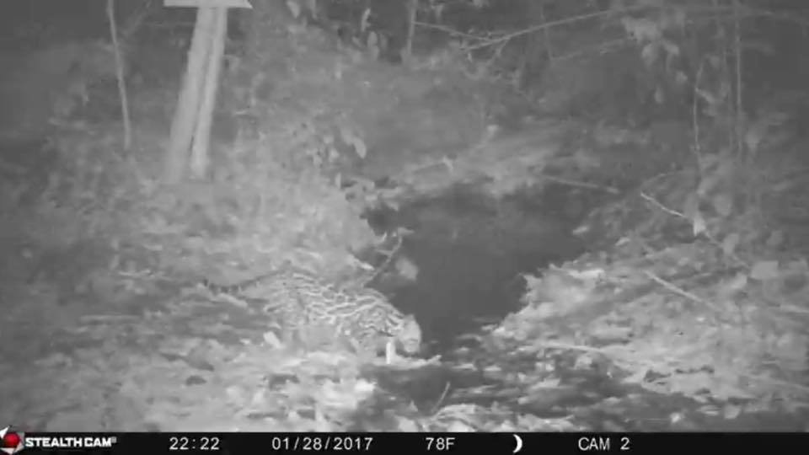
Figure 4. Camera trap photo of Leopardus pardalis
Ocelots are the most studied of the wild cats of the Osa Peninsula. They have been found to take down a variety of prey and they take advantage of seasonal changes in prey abundance. They are strongly nocturnal, and generally active for more than half of each 24-hour period (Nowell & Jackson, 1992). Males can travel up to twice the distance as females (Nowell & Jackson, 1992). Ocelots inhabit a wide spectrum of habitats which makes them more adaptable than margay.

Puma, Puma concolor
The Puma is a generalist, and therefore, the most successful felid in adapting to different environments. Although it is large, it is thought to be more closely related to small cats because it lacks enlarged vocal folds to roar (Nowell & Jackson, 1992). Pumas can vary in color, but on the Osa Peninsula they tend to be a tawny shade as shown in figure 3.

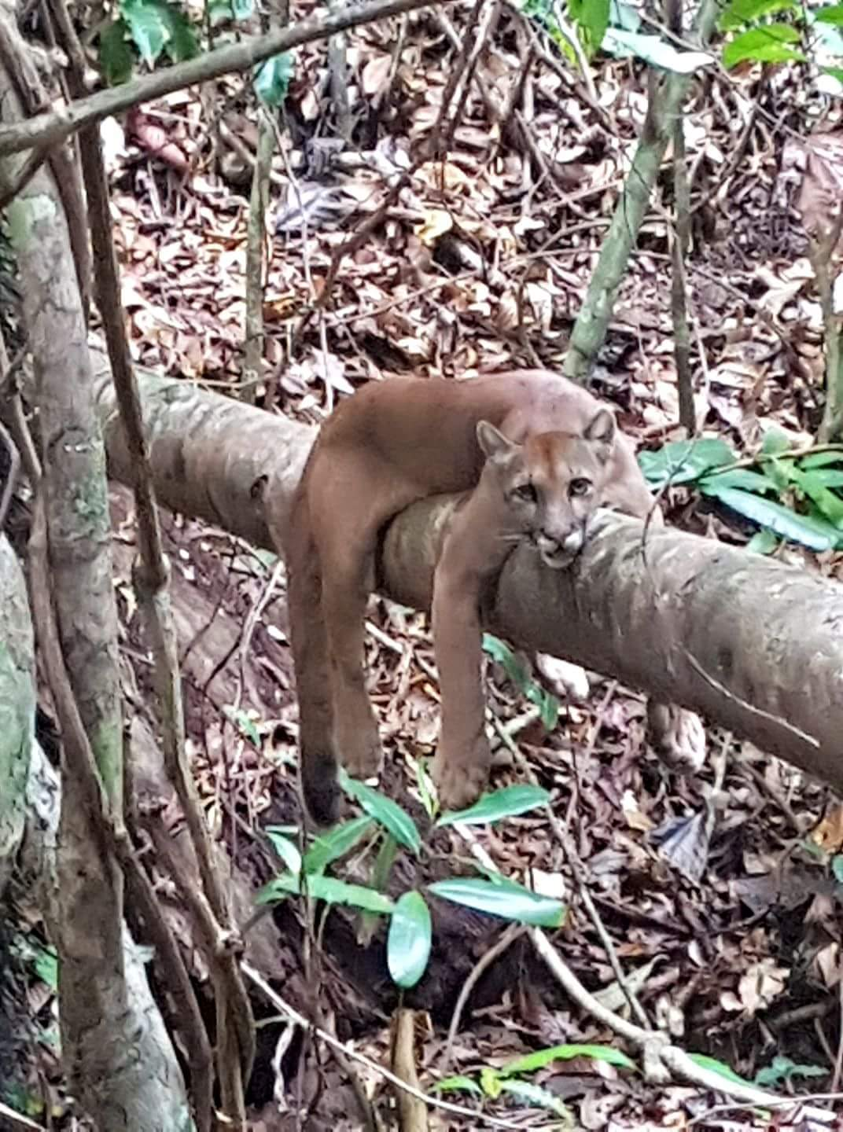
Figure 4. Puma Concolor
Pumas have the capability to take down large prey, but studies suggest that its low predation on large mammals like tapirs is linked to interspecific competition with the jaguar (Nowell & Jackson, 1992). Pumas are primarily nocturnal, but data from my last study shows that they are diurnal during the rainy season. On the study site there are at least two pumas, one male and one female.

Jaguarundi, Herpailurus yaguarondi
Like the puma, the jaguarundi does not have patterned fur and can vary in color. Little is known about their abundance on the Osa Peninsula. The last camera trap image captured near the study site was in 2016 of a black jaguarundi. They have a weasel-like appearance and can be confused with the tyra (Eira barbara). It also has an elongated head and short legs.
Jaguarundi frequently prey on birds and small mammals and reptiles (Nowell & Jackson, 1992).

Appendix II
Risk Management Plan
The following guidelines focus on establishing safe practices for fieldwork conducted in the tropical rain forests of Costa Rica. No amount of regulation is more effective in safe practices than personal vigilance. Therefore, proper training in safety concerns and mitigation are the best way to prevent safety issues. The purpose of this appendix is to identify potential hazards when working in a remote tropical rain forest location and establish procedures to reduce their likelihood. The following procedures are based on individuals with no known medical conditions and strong physical capabilities.
- Suitable maps should be created or provided of the fieldwork area, including information of support services such as medical clinics, hospitals, and telephone service areas.
- Properly informed designated contacts should be established within a home institution and the fieldwork site.
- Schedules and methods should be established for maintaining contact with a home institution.
- When planning coastal work, information about tides, currents, and weather conditions that could affect safety should be considered. In this study, tides are predicted by use of tidal watches and the individual is familiar with wave and current tendencies.
- Rainforest environments present hazards that university students are not accustomed to such as the possibility of a poisonous spider, snake, scorpion, or other organism being present in a cabin, bed sheets, boots, and in the field. Footwear should always be shaken out before being put on. The same goes for sheets, pillows, and clothes. High boots and knee socks should always be worn in the field to minimize scratches, wounds, or bites from insects, plants, and snakes.
- Do not touch spiders or questionable insects.
- One should never walk through tall grass bordering a tropical rainforest, regardless of protective attire. There is a high chance of snake bites.
- One should practice thorough tick checks after returning from the field during the dry season. These ticks are smaller and harder to find than North American ticks. They do not carry Lyme’s Disease, but they must be removed to avoid infections. Submersing and scrubbing oneself in water is the best way to rid oneself of these tiny ticks.
- Any insect bite, open wound, or scratch of ANY kind should be treated with Neosporin or disinfectant multiple times a day. Likelihood of infection is greatly enhanced in tropical environments.
- Use mosquito repellent and mosquito nets at night.
- Wash feet every night with soap to avoid fungus or “jungle foot rot,” especially in the rainy season.
- Never wear wet socks.
- Tetanus shots are a must when conducting any fieldwork, especially in developing countries.
- Hepatitis A & B, influenza, and rabies shots are recommended for Costa Rica. For any other tropical rainforest, malaria and yellow fever should be required. One should always carry a yellow fever card when traveling in South and Central America.
- Be aware of Dengue symptoms.
- One should never go into the field without a more than adequate water supply.
- One should avoid working in the field during dusk and dawn when large predators are most active.
- Never trust a wild animal, even if they are commonly seen as a docile species.
- Avoid resting against trees in the field or grabbing them for support when hiking, as there could be poisonous caterpillars or long spikes on certain species of palms.
- Do not work in the field alone.
- Always have a knife in the field.
- Be aware of where drinking water comes from, and how it is treated.
- When accustoming to food in a developing country for the first time, avoid uncooked vegetables and always wash fruit thoroughly.
- Never walk anywhere at night without a flashlight. The likelihood of stepping on a poisonous organism or running into a wild animal is high.
- Do not swim in streams or rivers unless you are sure they are free of crocodiles. Do not swim in ocean water near river mouths where aggressive bull sharks are common.
- Proper sun protection should be practiced especially if traveling on a boat. The water amplifies the sun’s rays so always have extra sunscreen for boat trips even in the early morning sun.
- Always have a first aid kit equipped with medicine for fever and diarrhea, disinfectants, Neosporin, a venom extractor, bandages, hand soap, tweezers, medical tape, butterfly bandages, antiseptic wipes, safety pins, and antihistamine tablets.
- Do not stand under coconut trees. A falling coconut can be fatal or cause serious head injury.
- In the case that one runs into a pack or White-lipped peccaries, the pack should be avoided. Packs of White-lipped peccaries have a distinct odor from a distance. If the odor is smelled, one should either take a different route or proceed with extreme caution. In the case that the peccaries detect one’s presence, and they charge, the best thing to do is climb a tree and wait for them to leave.
Jaguars and pumas have been known to attack humans. The best way to avoid this is to conduct fieldwork with a partner or group. Never run from a wild cat. They are more likely to attack if something is running from them.
- I am aware that the effect of fragrances on wild cats is unknown and therefore you will make sure to store the fragrances in a safe place and not get the fragrances on me.
This risk management plan was followed during the study.

